Adolfo Jimenez Prieto.

Victor de Vierna Valcarce.

Gonzalo Molpeceres Barrientos.

# ADMINS:

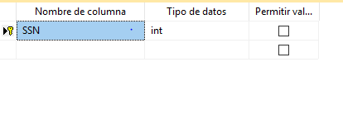

# ALBUM:

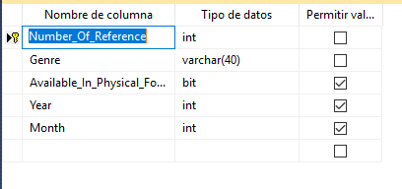

# ALBUM_AUTHORS:

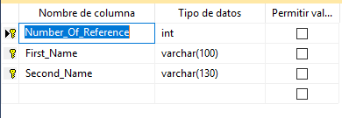

# ALBUM_TRACK_ART:

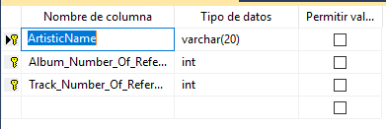

# ARTIST:

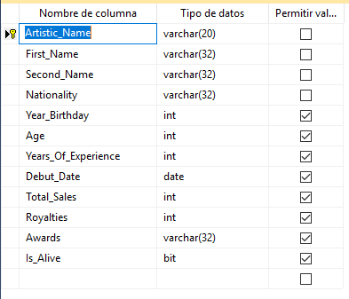

# ART_REC:

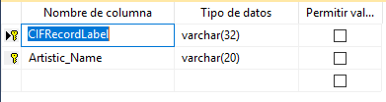

# BILLING_INFORMATION:

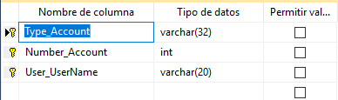

# COUPONS:

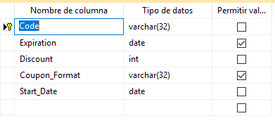

# COUPONS_NAME:

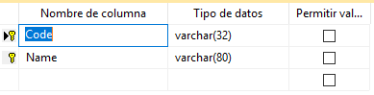

# DEVELOPERS:

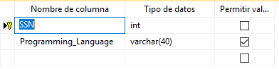

# DISTRADMIN:

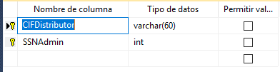

# DISTRIBUTOR:

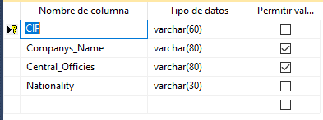

# EMPADRESS:

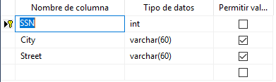

# EMPLOYEES:

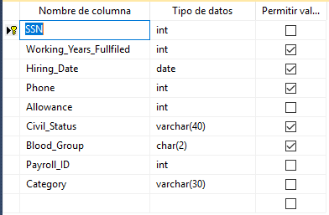

# LABELS_WORKED_WITH:

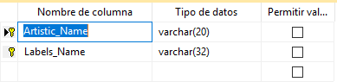

# MANAGADMIN:

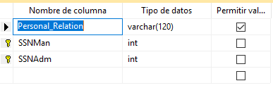

# MANAGDEV:

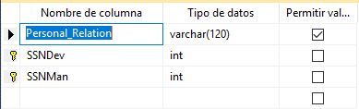

# MANAGERS:

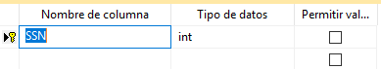

# PAYMENT:

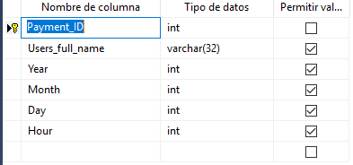

# PAYROLL:

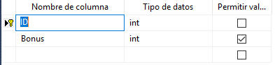

# PLAYLIST:

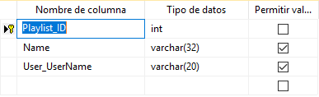

# PLAYTRACK:

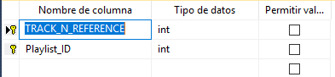

# PURCHASE_TRACKS:

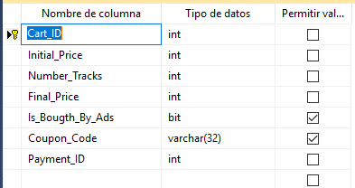

# RECORD_LABEL:

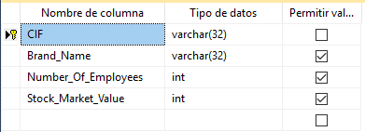

# RECORDDISTR:

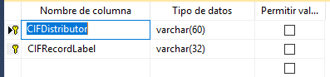

# TRACKS:

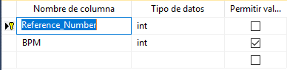

# USER:

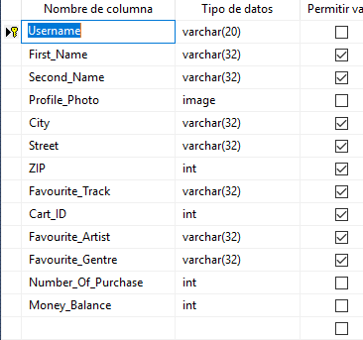

# USER_AUDIO_PREFERENCES:

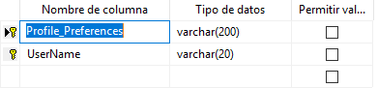

# USER_EMAIL:

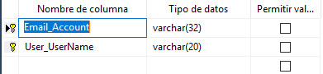

# USER_TRACK:

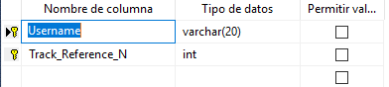

DATA TYPES

# ADMINS

|  |  |  |
| --- | --- | --- |
| SSN | int | NULL |

# ALBUM

|  |  |  |
| --- | --- | --- |
| Number_Of_Reference  Genre  Available_In_Physical_Form  Year  Month | int  varchar(40)  bit  int  int | NULL  NULL  NOT NULL  NOT NULL  NOT NULL |

# ALBUM_AUTHORS

|  |  |  |
| --- | --- | --- |
| Number_Of_Reference  First_Name  Second_Name | int  varchar(100)  varchar(130) | NULL  NULL  NULL |

# ALBUMTRACKART

|  |  |  |
| --- | --- | --- |
| ArtisticName  Album_Number_Of_Reference  Track_Number_Of_Reference | varchar(20)  int  int | NULL  NULL  NULL |

# ARTIST

|  |  |  |
| --- | --- | --- |
| Artistic_Name  First_Name  Second_Name  Nationality  Year_Birthday  Age  Years_Of_Experience  Debut_Date  Total_Sales  Royalties  Awards  Is_Alive | varchar(20)  varchar(32)  varchar(32)  varchar(32)  int  int  int  date  int  int  varchar(32)  bit | NULL  NULL  NULL  NULL  NOT NULL  NOT NULL  NOT NULL  NOT NULL  NOT NULL  NOT NULL  NOT NULL  NOT NULL |

# ArtRec

|  |  |  |
| --- | --- | --- |
| CIFRecordLabel  Artistic_Name | varchar(32)  varchar(20) | NULL  NULL |

# BILLING_INFORMATION

|  |  |  |
| --- | --- | --- |
| Type_Account  Number_Account  User_UserName | varchar(32)  int  varchar(20) | NULL  NULL  NULL |

# COUPONS

|  |  |  |
| --- | --- | --- |
| Code  Expiration  Discount  Coupon_Format  Start_Date | varchar(32)  date  int  varchar(32)  date | NULL  NOT NULL  NULL  NOT NULL  NULL |

# COUPONSNAME

|  |  |  |
| --- | --- | --- |
| Code  Name | varchar(32)  varchar(80) | NULL  NULL |

# DEVELOPERS

|  |  |  |
| --- | --- | --- |
| SSN  Programming_Language | int  varchar(40) | NULL  NOT NULL |

# DistrAdmin

|  |  |  |
| --- | --- | --- |
| CIFDistributor  SSNAdmin | varchar(60)  int | NULL  NULL |

# DISTRIBUTOR

|  |  |  |
| --- | --- | --- |
| CIF  Companys_Name  Central_Officies  Nationality | varchar(60)  varchar(80)  varchar(80)  varchar(30) | NULL  NOT NULL  NOT NULL  NULL |

# EMPADRESS

|  |  |  |
| --- | --- | --- |
| SSN  City  Street | int  varchar(60)  varchar(60) | NULL  NOT NULL  NOT NULL |

# EMPLOYEES

|  |  |  |
| --- | --- | --- |
| SSN  Working_Years_Fullfiled  Hiring_Date  Phone  Allowance  Civil_Status  Blood_Group  Payroll_ID  Category | int  int  date  int  int  varchar(40)  char(2)  int  varchar(30) | NULL  NOT NULL  NOT NULL  NOT NULL  NULL  NOT NULL  NOT NULL  NULL  NULL |

# LABELS_WORKED_WITH

|  |  |  |
| --- | --- | --- |
| Artistic_Name  Labels_Name | varchar(20)  varchar(32) | NULL  NULL |

# MANAGADMIN

|  |  |  |
| --- | --- | --- |
| Personal_Relation  SSNMan  SSNAdm | varchar(120)  int  int | NOT NULL  NULL  NULL |

# MANAGDEV

|  |  |  |
| --- | --- | --- |
| Personal_Relation  SSNDev  SSNMan | varchar(120)  int  int | NOT NULL  NULL  NULL |

# MANAGERS

|  |  |  |
| --- | --- | --- |
| SSN | int | NULL |

# PAYMENT

|  |  |  |
| --- | --- | --- |
| Payment_ID  Users_full_name  Year  Month  Day  Hour | int  varchar(32)  int  int  int  int | NULL  NOT NULL  NOT NULL  NOT NULL  NOT NULL  NOT NULL |

# PAYROLL

|  |  |  |
| --- | --- | --- |
| ID  Bonus | int  int | NULL  NOT NULL |

# PLAYLIST

|  |  |  |
| --- | --- | --- |
| Playlist_ID  Name  User_UserName | int  varchar(32)  varchar(20) | NULL  NOT NULL  NOT NULL |

# PLAYTRACK

|  |  |  |
| --- | --- | --- |
| TRACK_N_REFERENCE  Playlist_ID | int  int | NULL  NULL |

# PURCHASE_TRACKS

|  |  |  |
| --- | --- | --- |
| Cart_ID  Initial_Price  Number_Tracks  Final_Price  Is_Bougth_By_Ads  Coupon_Code  Payment_ID | int  int  int  int  bit  varchar(32)  int | NULL  NULL  NULL  NULL  NOT NULL  NOT NULL  NULL |

# RECORD_LABEL

|  |  |  |
| --- | --- | --- |
| CIF  Brand_Name  Number_Of_Employees  Stock_Market_Value | varchar(32)  varchar(32)  int  int | NULL  NOT NULL  NOT NULL  NOT NULL |

# RecordDistr

|  |  |  |
| --- | --- | --- |
| CIFDistributor  CIFRecordLabel | varchar(60)  varchar(32) | NULL  NULL |

# TRACKS

|  |  |  |
| --- | --- | --- |
| Reference_Number  BPM | int  int | NULL  NOT NULL |

# USER

|  |  |  |
| --- | --- | --- |
| Username  First_Name  Second_Name  Profile_Photo  City  Street  ZIP  Favourite_Track  Cart_ID  Favourite_Artist  Favourite_Gentre  Number_Of_Purchase  Money_Balance | varchar(20)  varchar(32)  varchar(32)  image  varchar(32)  varchar(32)  int  varchar(32)  int  varchar(32)  varchar(32)  int  int | NULL  NOT NULL  NOT NULL  NULL  NOT NULL  NOT NULL  NOT NULL  NOT NULL  NOT NULL  NOT NULL  NOT NULL  NULL  NULL |

# USER_AUDIO_PREFERENCES

|  |  |  |
| --- | --- | --- |
| Profile_Preferences  UserName | varchar(200)  varchar(20) | NULL  NULL |

# USER_EMAIL

|  |  |  |
| --- | --- | --- |
| Email_Account  User_UserName | varchar(32)  varchar(20) | NULL  NULL |

# USER_TRACK

|  |  |  |
| --- | --- | --- |
| Username  Track_Reference_N | varchar(20)  int | NULL  NULL  NULL |

DEFAULT

# ARTISTS:

Age INT DEFAULT 18

Years_Of_Experience INT DEFAULT 0

Total_Sales INT DEFAULT 0

Royalties INT DEFAULT 0

Is_Alive BIT DEFAULT 'SI'

# RECORD_LABEL:

Number_Of_Employees INT DEFAULT 0

# PAYROLL:

Bonus INT DEFAULT 0

# EMPLOYEES:

Working_Years_Fullfiled INT DEFAULT 0

Civil_Status VARCHAR(40) DEFAULT 'SINGLE'

# ALBUM:

Available_In_Physical_Format BIT DEFAULT 'NO'

CHECK CONSTRAINS

# Artists:

CK_ARTIST_YEARSOFEXPAG CHECK(Age >= 0)

CK_ARTIST_YEARSOFEXPY CHECK(Years_Of_Experience >= 0)

CHECK_ARTISTSALES CHECK(Total_Sales >= 0)

CHECK_ARTISTROYAL CHECK(Royalties >= 0)

CK_ARTIST_YEARSOFEXPA CHECK(Awards >= 0)

CK_ARTIST_ISALIVE CHECK(Is_Alive LIKE '[SI, NO]')

# COUPONS:

CHECK_COUPONSC CHECK(Code LIKE '[0-9][0-9][0-9][0-9][0-9]

[a-z,A-Z]')

# PURCHASE_TRACKS:

CHECK_PURCHASE_TRACKSI CHECK(Initial_Price >= 0)

CHECK_PURCHASE_TRACKSN CHECK(Number_Tracks >= 0)

CHECK_PURCHASE_TRACKSF CHECK(Final_Price >= 0)

# Users:

CHECK_USERNUM CHECK(Number_Of_Purchase >= 0)

# RECORD LABEL:

C_RECORD_LABELN CHECK(Number_Of_Employees >= 0)

# TRACKS:

CK_TRACKSBPM CHECK(BPM>=0)

CK_Year CHECK("Year" >= 0)

CK_Month CHECK("Month" >= 0)

# ALBUM:

CK_AvailablePhysical CHECK(Available_In_Physical_Format

LIKE '[SI, NO]')